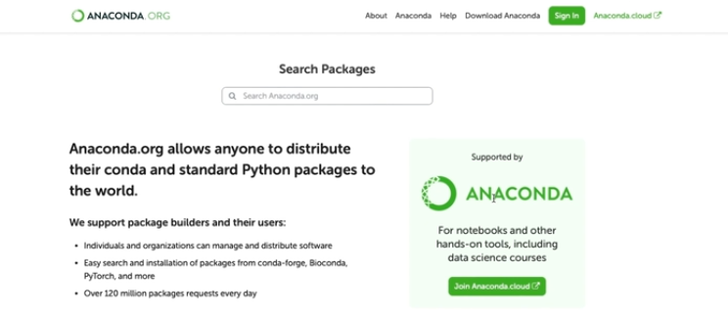

**What is Anaconda?**

Anaconda is an **open-source distribution** of Python and R, specifically designed for **data science** and **machine learning**. Imagine it as a **toolbox** that comes pre-loaded with all the essential libraries and tools you need for working in the field of data science. Whether you're just starting or you're an advanced data scientist, Anaconda provides the necessary tools to get started quickly without the hassle of finding and installing each package individually.

**Why Use Anaconda?**

Here are a few key reasons:

1. **Package Management**:
   * One of the biggest advantages of using Anaconda is how it simplifies the process of installing and managing different **libraries** and **packages**. For example, data science packages like NumPy, Pandas, and Matplotlib come pre-installed with Anaconda, so you don’t have to manually search for them.
2. **Isolated Environments**:
   * Anaconda allows you to create **isolated environments** for each project. This means that you can run different projects on the same machine, each using different versions of libraries, without conflicts. For example, one project can use TensorFlow 1.x, and another can use TensorFlow 2.x, and both will work smoothly.
3. **Anaconda Navigator**:
   * Anaconda comes with a graphical interface called the **Anaconda Navigator**. It's a user-friendly tool that helps you manage environments, install new packages, and launch tools like **Jupyter Notebooks**—all without needing to use the command line. This makes it a great choice for beginners who are not comfortable with terminal commands.
4. **Cross-Platform**:
   * Anaconda works on **Windows, macOS, and Linux**, making it accessible no matter what operating system you're using.

In terms of package manager you can say Anaconda like pip or poetry but **pip** and **Poetry** are focused on managing Python libraries, while **Conda** goes beyond that to handle data science libraries and dependencies more effectively. If you're working with Python and R in the data science field, Conda is often more convenient because it can manage both the environment and the packages seamlessly.

**Jupyter**

**Why is Jupyter Notebook Often Used for Prototyping?**

Jupyter Notebooks are ideal for **prototyping** because of the following reasons:

1. **Interactive Development**:
   * You can run small chunks of code (called **cells**) one at a time, test them, and see results immediately. This makes it perfect for quickly experimenting with different ideas, algorithms, and visualizations without having to run the entire program.
   * You can write code in one cell, make changes, and re-run only that part without affecting other parts of the notebook. This helps you iterate quickly when testing new concepts or fixing issues.
2. **Rapid Experimentation**:
   * When working on data science projects or machine learning models, you often need to test various configurations, models, or approaches. Jupyter makes it easy to tweak code, adjust parameters, and observe results immediately. You don’t need to set up a full, structured codebase when trying out ideas quickly.
   * It’s common to explore and visualize data in real time by generating plots and graphs directly in the notebook using libraries like **Matplotlib** or **Seaborn**.
3. **Ease of Documentation**:
   * You can document your thought process, add equations, and explain the code as you go using **Markdown cells**. This makes Jupyter a great tool for sharing initial ideas and early-stage projects with teammates.
   * You can combine code, explanations, and visualizations in one place, which makes it easier to iterate and explain what you’re doing during the **prototyping phase**.

**Jupyter is Not Always Suitable for Production. Why?**

1. **Lack of Structure**:
   * **Production code** typically needs to be well-structured, modular, and tested. Jupyter Notebooks are more focused on quick, interactive exploration rather than following best practices for maintainable, scalable code.
   * In production, you usually need a well-organized project with separate modules, clear function definitions, and reusable components, which can be harder to manage in notebooks.
2. **Version Control and Collaboration**:
   * Jupyter Notebooks don’t work as well with **version control systems** (like Git) compared to regular Python scripts. Because the output of the cells (like charts, images) is also stored with the code, it can make it difficult to manage version history.
   * Collaboration in Jupyter is not as streamlined. When working on large projects with multiple developers, using scripts and proper version control tools is more effective than working in notebooks.
3. **Reproducibility Issues**:
   * If someone reruns a Jupyter Notebook without following the exact order of cells or dependencies, they might not get the same results. In production, it's critical that code is **reliable** and **reproducible** every time.
   * Jupyter relies on the **order of cell execution**, which can introduce hidden bugs. For example, you may define a variable in one cell and forget to rerun it later, but in scripts, the order of code execution is always clear.
4. **Testing and Debugging**:
   * Production code needs to be **tested** rigorously. You need unit tests, integration tests, and other quality checks, which are harder to organize and maintain in a Jupyter Notebook.
   * Debugging can also be harder in notebooks compared to using a standard **Integrated Development Environment (IDE)** like **PyCharm** or **VSCode**.
5. **Performance Optimization**:
   * Notebooks are great for small-scale experiments, but for **large-scale data processing** or **real-time applications**, you’ll need more performance optimization, which is better handled in a proper development environment.

**What to Use for Production?**

Once you've built a prototype in Jupyter and want to take it to production, you typically need to transition to more robust tools like:

1. **Python Scripts and Modules**:
   * After you’ve prototyped your logic, it’s common to convert Jupyter Notebooks into **Python scripts** (.py files). These can then be integrated into a more structured codebase with proper function and class definitions.
   * Production systems also need automation tools (e.g., **Airflow**), monitoring, logging, and error handling, which are better suited for Python scripts.
2. **Frameworks**:
   * For machine learning, frameworks like **TensorFlow**, **PyTorch**, and **Scikit-learn** are often used in production with well-structured pipelines.
   * For deploying models, tools like **Flask**, **FastAPI**, or **Django** are used to build APIs for serving machine learning models or other services.
3. **Version Control and CI/CD**:
   * In production, you’ll need to work with **version control** (Git) and implement **Continuous Integration/Continuous Deployment (CI/CD)** pipelines to ensure smooth updates and collaboration among team members.
   * These tools ensure that code is properly tested and deployed without breaking the system.
4. **Containerization and Deployment**:
   * You’ll likely need to deploy your application or model using **containers** like **Docker** or deploy it in the cloud (e.g., AWS, GCP, Azure) for scalability.
   * Jupyter is not built for deployment, but you can containerize Python scripts or model APIs for efficient scaling and serving.

**ML- demo 1**

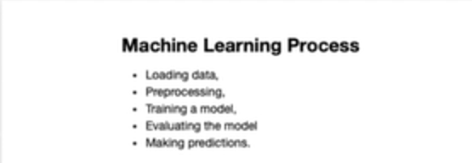

The **Machine Learning (ML) process** typically involves several key steps that help you transform raw data into a working model that can make predictions or decisions. Here’s an overview of each step:

**1. Loading the Data**

The first step is to load the data you’ll use to train your machine learning model. This data can come from a variety of sources:

* **CSV files** or spreadsheets
* **Databases**
* **APIs**
* **Online datasets** (like those from Kaggle or UCI Machine Learning Repository)

The idea is to read the raw data into a format that can be used by a machine learning algorithm, like a **Pandas DataFrame** in Python.

**2. Preprocessing the Data**

Preprocessing is crucial because raw data often contains missing values, outliers, or irrelevant features that can affect model performance. Preprocessing includes:

* **Handling missing values**:
  + Remove or fill in missing values using techniques like mean/median imputation or interpolation.
* **Feature scaling**:
  + Some models perform better when all features are on the same scale. Common methods include:
    - **Standardization**: Scaling data to have a mean of 0 and a standard deviation of 1.
    - **Normalization**: Rescaling data to a [0, 1] range.
* **Encoding categorical variables**:
  + Convert categorical features (like "yes/no" or "male/female") into numerical values using techniques like **One-Hot Encoding** or **Label Encoding**.
* **Splitting the data**:
  + Split your dataset into **training data** and **testing data**. This ensures you can train your model on one portion of the data and evaluate it on another.

**3. Training the Model**

Once the data is preprocessed, you can train your machine learning model. The model is trained on the **training dataset**, which means the model "learns" patterns from this data by adjusting its internal parameters.

You’ll select an appropriate algorithm based on the type of task (classification, regression, etc.), for example:

* **Linear Regression** for regression problems.
* **Logistic Regression** for binary classification problems.
* **Decision Trees**: A tree-like structure where data is split based on features to make predictions by following a path from the root to a leaf node (outcome).
* **Random Forests**: An ensemble of multiple decision trees that vote collectively to improve prediction accuracy and reduce overfitting.
* **Support Vector Machines (SVM)**: A model that finds the best boundary (hyperplane) to separate data into distinct classes by maximizing the margin between them.
* **Neural Networks** for deep learning tasks.

**4. Evaluating the Model / testing**

After training the model, it's important to evaluate how well it performs on unseen data (the **test set**). This helps you understand whether your model is overfitting (memorizing training data but performing poorly on new data) or underfitting (failing to capture patterns in the training data).

Common evaluation metrics include:

* **Accuracy**: The percentage of correctly predicted instances.
* **Precision/Recall/F1-Score**: Used for binary classification, especially when the data is imbalanced.
* **Mean Squared Error (MSE)**: Common in regression tasks to measure the difference between predicted and actual values.
* **Confusion Matrix**: Helps visualize the performance of classification models.

**5. Making Predictions**

Once the model has been evaluated and is performing well on the test data, it can be used to make predictions on new or unseen data.

In a real-world application, you might deploy this model to make predictions on data that you encounter in the future. For example, if you were using the model to predict whether an email is spam or not, you’d use the trained model to classify new incoming emails.

**Summary of Steps:**

1. **Loading the Data**: Load your dataset (CSV, database, etc.) into a usable format.
2. **Preprocessing**: Clean and prepare the data (handle missing values, scale features, encode categories, and split the data into training and testing sets).
3. **Training the Model**: Fit the model to your training data and learn from it.
4. **Evaluating the Model**: Test the model’s performance using evaluation metrics like accuracy or MSE.
5. **Making Predictions**: Use the trained model to make predictions on new data.

This overall process ensures that a machine learning model can learn from past data and generalize well to future, unseen data.

Now in the ML Demo 1 we have basically done Logistic Regression on Iris Dataset. You can check code here: <http://localhost:8889/notebooks/ML%20demo/ML%20demo-1.ipynb?> (remember before opening this notebook first launch the jupyter notebook using Anaconda navigator).